Line of Business: User Interface Solution

Exercise 1: Investigation

1. Open config.xml. What are the names of the two configuration parameters that control whether the "Choose by Coverage" or "Choose by Coverage Type" menus are displayed for a given line of business?

ShowNewExposureChooseByCoverageMenuForLossTypes and   
ShowNewExposureChooseByCoverageTypeMenuForLossTypes

2. Which loss type in the base application is not listed in the default settings for these two parameters? (If necessary, view the LossType typelist in the data dictionary or in Studio.)

Workers' Comp (WC)

3. Modify config.xml as described below. (You must restart ClaimCenter to deploy config.xml changes.)

* For auto claims (such as claim 235-53-365870), exposures are created only as shown below:

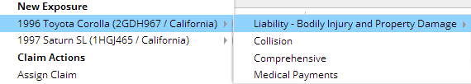

* For property claims (such as claim 426-24-366070), exposures are created only as shown below: 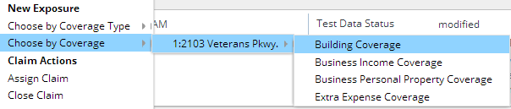
* For general liability claims (such as 345-50-123321), exposures are created only as shown below:

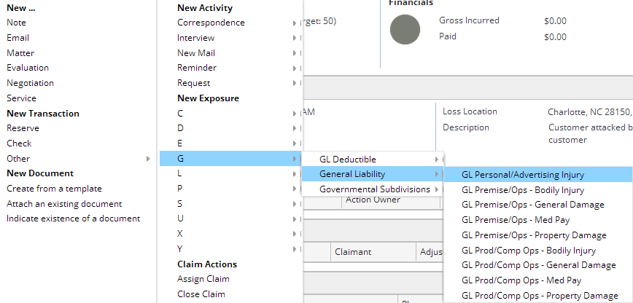

<param name="ShowNewExposureChooseByCoverageTypeMenuForLossTypes"

value="PR,GL,TRAV"/>

<param name="ShowNewExposureChooseByCoverageMenuForLossTypes"

value="AUTO,PR,TRAV"/>

**Exercise 2: Configuration**

Configure ClaimCenter to meet the following customer requirement from Acme Insurance.

**Requirement: Eroded Property Damage for Erosion Coverage**

The solution is shown in the screenshots below. (The display keys have not been included.)

Add new exposure type:

(see previous lab solution – Requirement #2).

Then create a new CoverageSubtype and ExposureType for Eroded Dwelling Damage. Retire the previous CoverageSubtype.

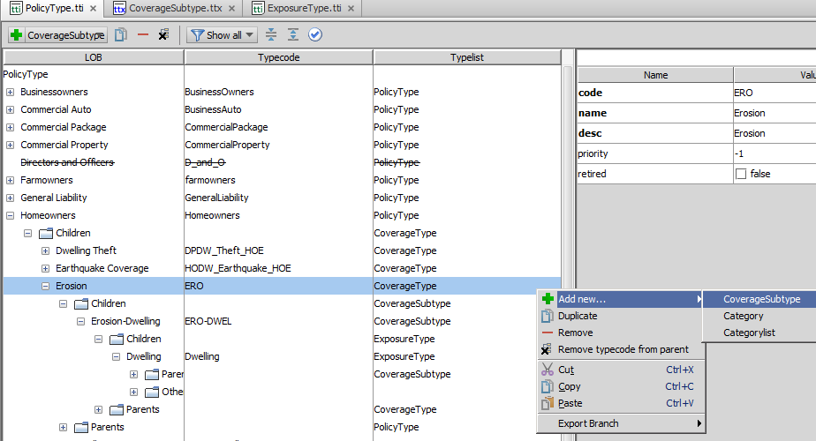

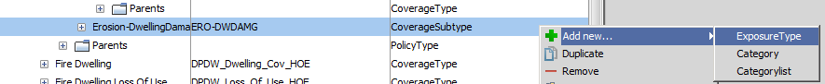

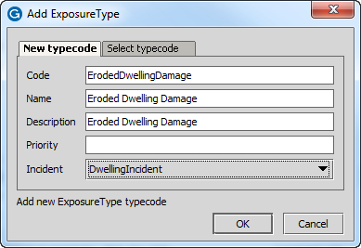

Save your new ExposureType

Retire the old ERO-DWEL CoverageSubtype from the previous lab (the new CoverageSubtype is shown directly below the retired one):

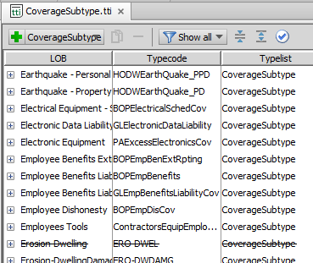

Copy and paste the two DVs, making them for the ErodedDwellingDamage mode. Add a verbatim element label to the panel ref above the referenced detail view.

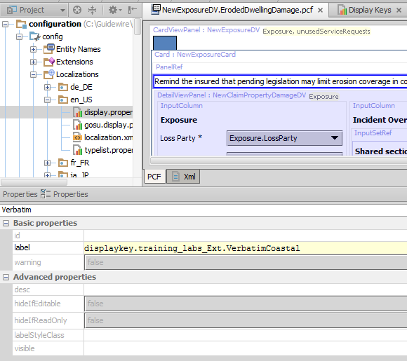

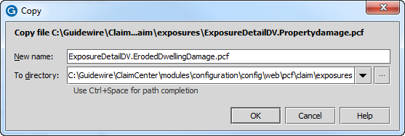

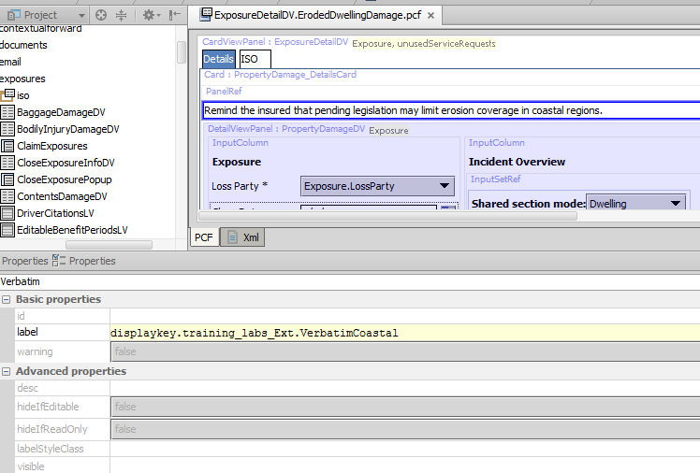

Duplicate the two input sets (one from each DV) for the ErodedDwellingDamage mode.

Note: You cannot change mode on existing PCFs but you can change mode for new PCFs that you create.

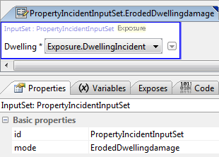

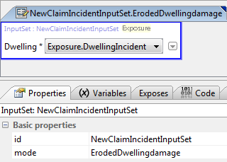

You will see the ErodedDwellingDamage option in the modal dropdowns in each of the new detail views.

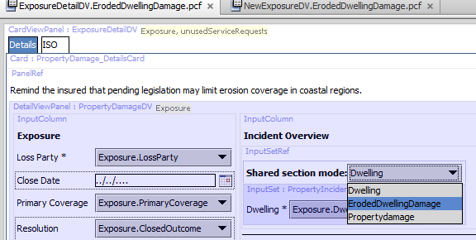

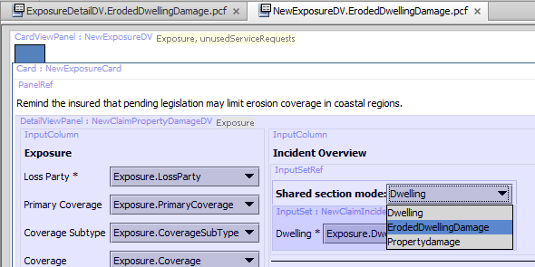 Add a line to the initializeIncident() function to capture this new exposure type case.

